>>>Event Loop in NodeJS: How It Works!<<<

We must have come across the terms ‘Callbacks’, ‘Non-blocking I/O’ and ‘Event Looping’ while learning or understanding NodeJS.

Here is an attempt to explain!

>>>What is Event Looping?

>>>>At start, we will go through concepts of Blocking and Non-Blocking executions, then jumping on to the ‘Event Loops by Reactor Pattern’!
Consider examples like reading a file into the application, or an http request to a third party api’s. There are two ways we can perform these I/O operations:

- Blocking I/O: Where, application will make a function call and pause its execution at this point until the data is received.

- Non-Blocking I/O: Where, application will make a function call, and, without waiting for the results, continue its execution.

Former is called as ‘Synchronous’, while later is called as Asynchronous’ nature of execution, and NodeJS as you know, is Asynchronous in nature.

So, being single-threaded, How NodeJS works asynchronously?

Answer is, Reactor Pattern - which is at the centre of NodeJS.

But, what is Event Looping?

“It is a magical place filled with unicorns and rainbows.“ ☺
To explain this, we will compare two patterns of Event-Driven programming:

- Busy Waiting:

In which, continuous checks on resources is done to see if data is ready for further processing, - called as Active Polling

resources = [socketA, socketB, pipeA];
while( !resources.isEmpty()) {
for (i = 0; i < resources.length; i++) {
resource = resources[i];
//try to read
var data = resource.read();
if(data === NO_DATA_AVAILABLE)
//there is no data to read at the moment
continue;
if(data === RESOURCE_CLOSED)
//the resource was closed, remove it from the list
resources.remove(i);
else
//some data was received, process it
consumeData(data);
}
}

Though, it is the simple way to implement asynchronous, event-driven behaviour, it’s not efficient. As this process will keep running continuously, it will use the CPU extensively.

- Reactor Pattern:
>>>To understand Reactor Pattern, confider below
Reactor Pattern is made of:

- Resources:
that are shared by multiple applications for I/O operations, generally slower in executions.
- Synchronous Event Demultiplexer / Event Notifier:
This uses Event Loop for blocking on all resources. When a set of I/O operations completes, the Event Demultiplexer pushes the new events into the Event Queue.

- Event Loop and Event Queue:
Event Queue queues up the new events occurred along with its event-handler, <event, event-handler> pair.

- Request Handler / Application:
This is the application that provides the handler to be executed for the registered events on resources.

See below diagram for understanding of Reactor Pattern and the place for Event Loop:

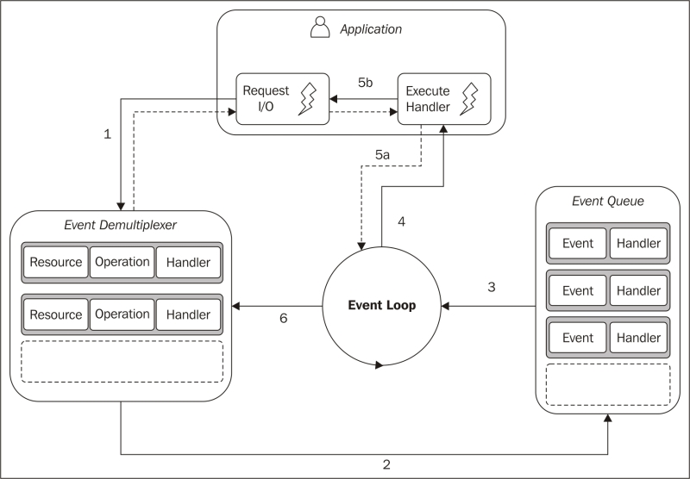
Pseudo code for this can be:

socketA, pipeB;
watchedList.add(socketA, FOR_READ); //[1]
watchedList.add(pipeB, FOR_READ);
while(events = demultiplexer.watch(watchedList)) { //[2]
//event loop
foreach(event in events) { //[3]
//This read will never block and will always return data
data = event.resource.read();
if(data === RESOURCE_CLOSED)
//the resource was closed, remove it from the watched list
demultiplexer.unwatch(event.resource);
else
//some actual data was received, process it
consumeData(data);
}
}

// todo :

https://www.packtpub.com/mapt/book/Web-Development/9781783287314/1/ch01lvl1sec09/The+reactor+pattern

file:///H:/ebook-daraz-Node.js%20Design%20Patterns%20-%20Casciaro,%20Mario.pdf

https://gist.github.com/kv89/6f483278194fcc58949789a33f6d1399

http://www.puncsky.com/blog/2015/01/13/understanding-reactor-pattern-for-highly-scalable-i-o-bound-web-server/

https://en.wikipedia.org/wiki/Busy_waiting
https://en.wikipedia.org/wiki/Reactor_pattern#Limitations

